**What is Acid Rain?**

Acid rain is a result of air pollution. When any type of fuel is burnt, lots of different chemicals are produced. The smoke that comes from a fire or the fumes that come out of a car exhaust contains lots of invisible gases that can be even more harmful to our environment.  
  
Power stations, factories and cars all burn fuels and therefore they all produce polluting gases. Some of these gases (especially nitrogen oxides and sulphur dioxide) react with the tiny droplets of water in clouds to form sulphuric and nitric acids. The rain from these clouds then falls as very weak acid - which is why it is known as "acid rain".  The release of sulphur dioxide can also occur naturally when a volcano erupts.

* Sulphur dioxide and water form sulphurous acid (H2SO3)   
  SO2(g) + H2O(l) --> H2SO3(aq)
* Some oxides of nitrogen like nitrogen dioxide (NO2) react with water to form nitrous acid (HNO2) and nitric acid (HNO3)   
  2NO2(g) + H2O(l) -> HNO2(aq) + HNO3(aq)
* Carbon dioxide in the air can dissolve in rain water to form carbonic acid, (H2CO3).
* CO2 + H2O H2CO3

How acidic is Acid Rain?

Unpolluted rain would have a pH value of between 5 and 6. When the air becomes more polluted with nitrogen oxides and sulphur dioxide the acidity can increase to a pH value of 4.

[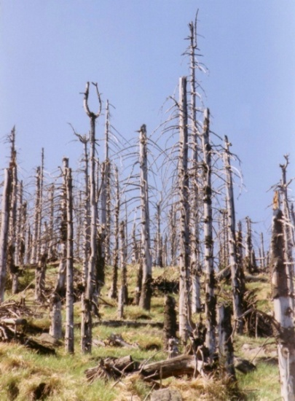](http://upload.wikimedia.org/wikipedia/commons/6/6e/Waldschaeden_Erzgebirge_3.jpg)Effects of Acid Rain

Acid rain can be carried great distances in the atmosphere. The acid can also take the form of snow, mists and dry dusts. The rain sometimes falls many miles from the source of pollution but wherever it falls it can have a serious effect on soil, trees, buildings and water.

- Erodes buildings and statues (limestone)   
- Takes away valuable minerals in the soil (bad for agriculture)

- Some microbes are unable to tolerate changes to low pHs and are killed.

- Acid rain cause calcium to be leached from the needles of red spruce, these trees become less cold tolerant and exhibit winter injury and even death.

- Increases toxic materials taken up by plant roots (root damage, stunted growth)  
- Lowered pH of lakes, rivers and streams is toxic to fish and other aquatic species

-Loss of aquatic species in lakes results in a break in the food chain

-Breathing and lung problems in children and adults who have asthma and in children have been linked to acid air pollution. Everything that we eat, drink, and breathe has at one time come in contact with acid deposits.

What can be done?

1. **Reduce emissions:  
   •** Burning fossil fuels is still one of the cheapest ways to produce electricity so people are now researching new ways to burn fuel which don't produce so much pollution.  
   • Governments need to spend more money on pollution control even if it does mean an increase in the price of electricity.  
   • Sulphur can also be 'washed' out of smoke by spraying a mixture of water and powdered limestone into the smokestack.  
   • Cars are now fitted with catalytic converters which remove three dangerous chemicals from exhaust gases.
2. **Find alternative sources of energy**  
   • Governments need to invest in researching different ways to produce energy. E.g. hydroelectric and nuclear power.
3. 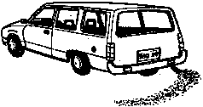**Conserving resources**  
   • Use public transport rather than always travelling by car.  
   • Save energy by switching off lights when they are not being used and using energy-saving appliances - when less electricity is being used, pollution from power plants decreases.  
   • Walking, cycling and sharing cars all reduce the pollution from vehicles.

Give three ways that acid rain can be harmful to natural and/or man-made environments.

1. __________________________________________________________________________

__________________________________________________________________________

2. __________________________________________________________________________

__________________________________________________________________________

3. __________________________________________________________________________

__________________________________________________________________________

Explain two things that humans can do to reduce the occurrence of acid rain. How does this help reduce acid rain?

1. __________________________________________________________________________

__________________________________________________________________________

__________________________________________________________________________

2. __________________________________________________________________________

__________________________________________________________________________

__________________________________________________________________________